Figure 1: Produce by Farm 2

Figure 2: Water Filter 3

Figure 3: Essay lifecycle 4

[Figure 4: Lipoprotein distribution 5](https://d.docs.live.net/81d396183ba7f031/School/CWU%202020/CS%20325/Lab%206a/Lorem%20ipsum_Blazina.docx#_Toc70363558)

Table 1: Energy production by major source from 1960 to 1980 1

Table 2: Proportion of Errors in Younger and Older Groups 2

# Lorem ipsum file for Visualizations Lab:

Lorem ipsum dolor sit amet, consectetuer adipiscing elit. Maecenas porttitor congue massa. Fusce posuere, magna sed pulvinar ultricies, purus lectus malesuada libero, sit amet commodo magna eros quis urna. Nunc viverra imperdiet eni.

Table : Energy production by major source from 1960 to 1980

|  |  |  |  |  |  |
| --- | --- | --- | --- | --- | --- |
| **Table 1: Energy production by major source from 1960 to 19801** | | | | | |
| **Year** | **Total production (quad Btu)** | **Percent production** | | | |
| **Coal** | **Petroleum** | **Natural Gas** | **Other2** |
| 1960 | 41.5 | 26.1 | 36.0 | 34.0 | 3.9 |
| 1970 | 62.1 | 23.5 | 32.9 | 38.9 | 4.7 |
| 1980 | 64.8 | 28.7 | 28.2 | 34.2 | 8.9 |

*1 Source*: U.S. Energy Information Administration, *Annual Energy Review*

*2* Includes hydropower, nuclear power, geothermal power, and others.

Lorem ipsum dolor sit amet, consectetuer adipiscing elit. Maecenas porttitor congue massa. Fusce posuere, magna sed pulvinar ultricies, purus lectus malesuada libero, sit amet commodo magna eros quis urna. Nunc viverra imperdiet eni.

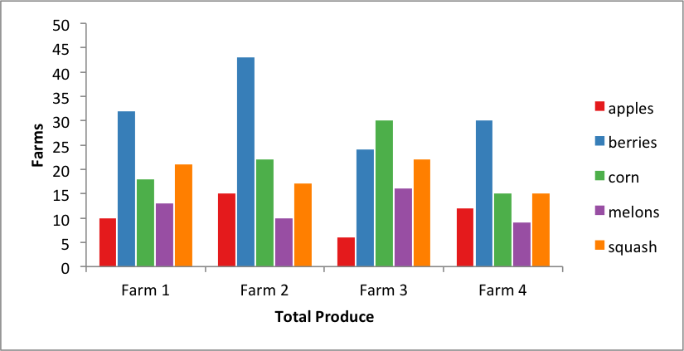**Produce by Farm**

**Produce (lbs)**

**Number of Farms**

Figure : Produce by Farm

Fusce est. Vivamus a tellus. Pellentesque habitant morbi tristique senectus et netus et malesuada fames ac turpis egestas. Proin pharetra nonummy pede.

Mauris et orci. Aenean nec lorem. In porttitor. Donec laoreet nonummy augue.

Table : Proportion of Errors in Younger and Older Groups

|  |  |  |  |  |  |  |  |
| --- | --- | --- | --- | --- | --- | --- | --- |
| *Proportion of Errors in Younger and Older Groups* | | | | | | | |
| Level of difficulty | Younger | | |  | Older | | |
| *n* | *M (SD)* | 95% CI |  | *n* | *M (SD)* | 95% CI |
| Low | 12 | .05 (.08) | [.02, .11] |  | 18 | .14 (.15) | [.08, .22] |
| Moderate | 15 | .05 (.07) | [.02, .10] |  | 12 | .17 (.15) | [.08, .28] |
| High | 16 | .11 (.10) | [.07, .17] |  | 14 | .26 (.21) | [.15, .39] |
| *Note.* CI = confidence interval. | | | | | | | |

Lorem ipsum dolor sit amet, consectetuer adipiscing elit. Maecenas porttitor congue massa. Fusce posuere, magna sed pulvinar ultricies, purus lectus malesuada libero, sit amet commodo magna eros quis urna.

Nunc viverra imperdiet enim. Fusce est. Vivamus a tellus.

Pellentesque habitant morbi tristique senectus et netus et malesuada fames ac turpis egestas. Proin pharetra nonummy pede. Mauris et orci.

Aenean nec lorem. In porttitor. Donec laoreet nonummy augue.

Suspendisse dui purus, scelerisque at, vulputate vitae, pretium mattis, nunc. Mauris eget neque at sem venenatis eleifend. Ut nonummy.

Fusce aliquet pede non pede. Suspendisse dapibus lorem pellentesque magna. Integer nulla.

**Water Filtration System Composition**

A close up of a water filtration system using sand.



Figure : Water Filter

Suspendisse dui purus, scelerisque at, vulputate vitae, pretium mattis, nunc. Mauris eget neque at sem venenatis eleifend. Ut nonummy. Fusce aliquet pede non pede.

Suspendisse dapibus lorem pellentesque magna. Integer nulla. Donec blandit feugiat ligula. Donec hendrerit, felis et imperdiet euismod, purus ipsum pretium metus, in lacinia nulla nisl eget sapien

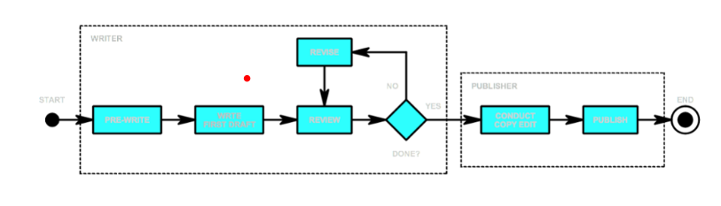**Essay Lifecycle Diagram**

Figure : Essay lifecycle

Lorem ipsum dolor sit amet, consectetuer adipiscing elit. Maecenas porttitor congue massa. Fusce posuere, magna sed pulvinar ultricies, purus lectus malesuada libero, sit amet commodo magna eros quis urna. Nunc viverra imperdiet enim.Fusce est. Vivamus a tellus. Pellentesque habitant morbi tristique senectus et netus et malesuada fames ac turpis egestas. Proin pharetra nonummy pede.

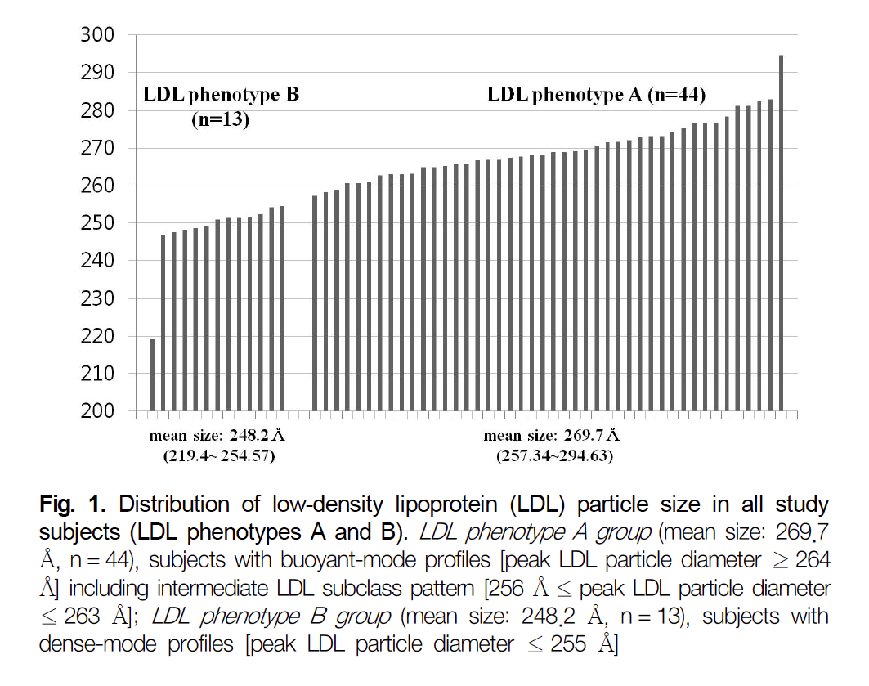**Distribution of Lipoproteins**

**Phenotypes**

**Particle Diameter**

Figure : Lipoprotein distribution

Mauris et orci. Aenean nec lorem. In porttitor. Donec laoreet nonummy augue.

Suspendisse dui purus, scelerisque at, vulputate vitae, pretium mattis, nunc. Mauris eget neque at sem venenatis eleifend. Ut nonummy. Fusce aliquet pede non pede.

Suspendisse dapibus lorem pellentesque magna. Integer nulla. Donec blandit feugiat ligula. Donec hendrerit, felis et imperdiet euismod, purus ipsum pretium metus, in lacinia nulla nisl eget sapien.

Donec ut est in lectus consequat consequat. Etiam eget dui. Aliquam erat volutpat. Sed at lorem in nunc porta tristique.

Proin nec augue. Quisque aliquam tempor magna. Pellentesque habitant morbi tristique senectus et netus et malesuada fames ac turpis egestas. Nunc ac magna.